Part1 Result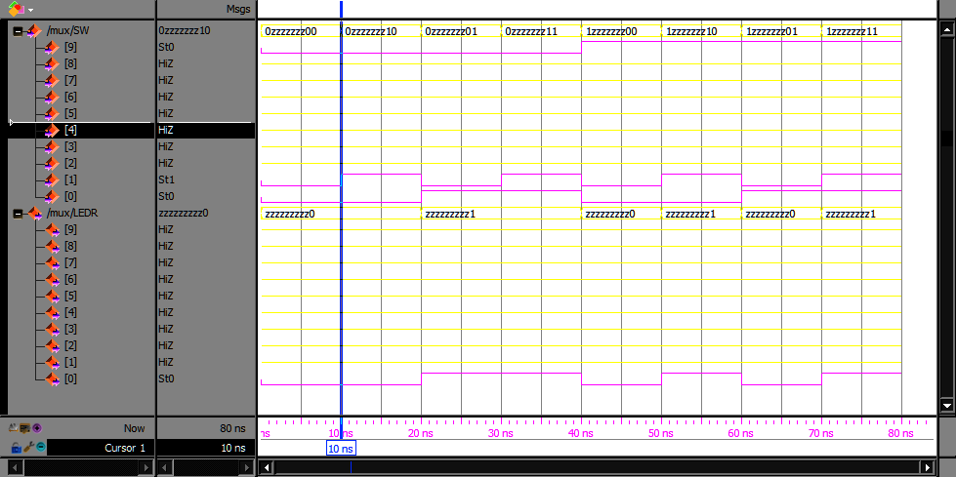

Part2 Simulation a)

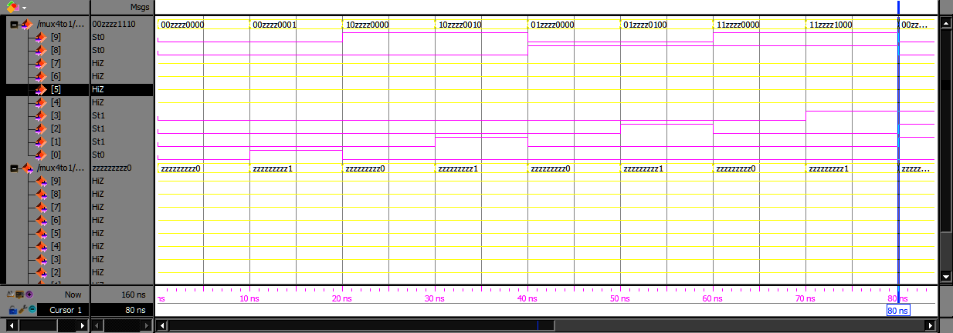

Part2 Simulation b)

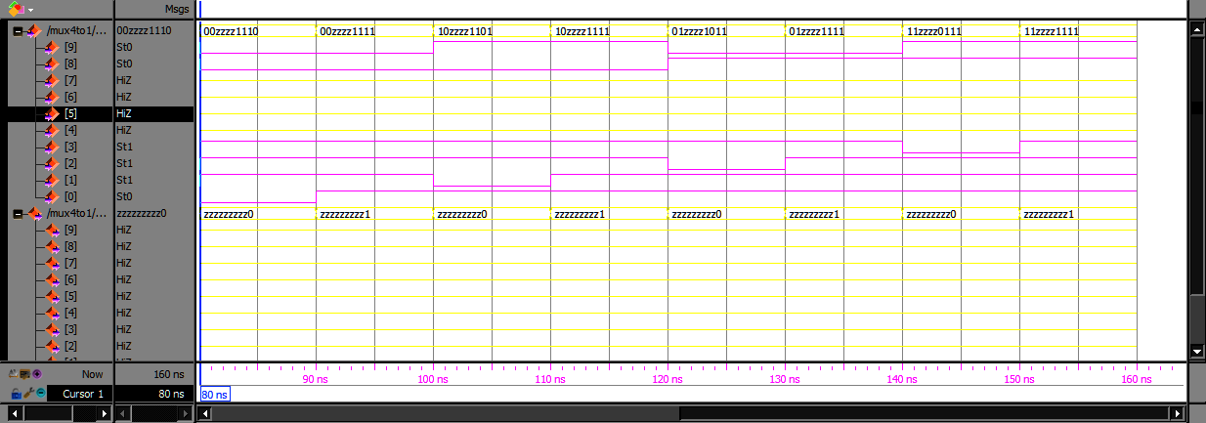

Part3 Simulation – Extra – Testing the whole truth table a)

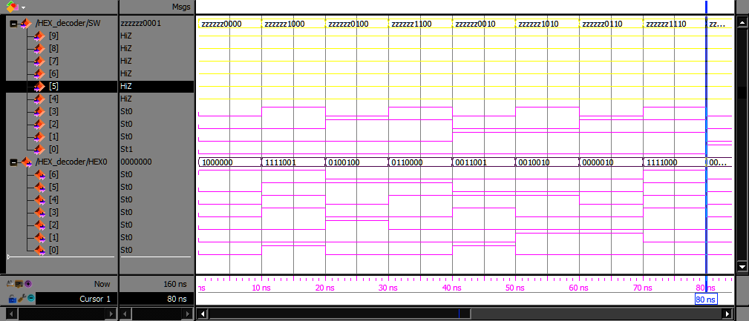

Part3 Simulation – Extra – Testing the whole truth table b)

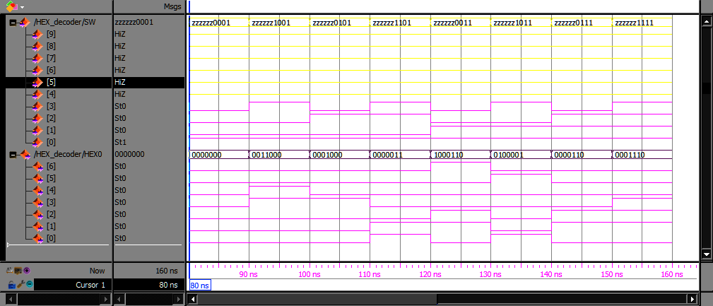Part3.3 Simulation Result: JINGQIYA -> 546A7B92